Experiment Number : 01 Date:

Installation of Java and Simple Java Programs
Aim:
To install Java Development Kit (JDK), configure the environment, and write simple Java programs including Hello World.
PRE LAB EXERCISE
QUESTIONS
- What is JDK and why is it required?
JDK (Java Development Kit) is a software package that provides tools to develop, compile, and run Java programs.
It is required because it contains the compiler (javac), libraries, and other tools needed to create Java applications.

- Difference between JDK, JRE, and JVM.
JVM (Java Virtual Machine): Executes Java bytecode and provides a runtime environment.
JRE (Java Runtime Environment): Contains JVM and libraries needed to run Java programs.
JDK (Java Development Kit): Contains JRE plus development tools to write and compile Java programs.
In short: JDK = JRE + development tools, and JRE = JVM + libraries.

- What is the purpose of the main() method in Java?
The main() method is the entry point of a Java program.
Execution of a Java program starts from the main() method, and without it, the program cannot run.

IN LAB EXERCISE
Objective:
To verify Java installation and execute a basic Java program.
INSTALLATION STEPS:
STEP 1: Open Browser
- Open your browser and go to the official URL Eclipse Downloads page.

STEP 2: Download Eclipse Installer
- Then, click on the "Download" button to download Eclipse IDE.

STEP 3: Download EXE
- Now, click on the "Download x86_64" button.
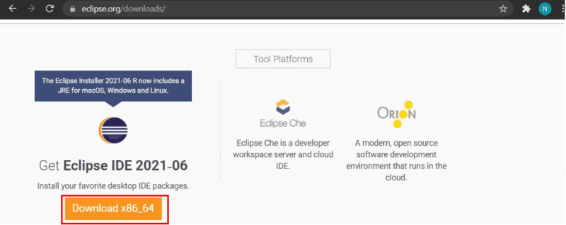

STEP 4: Then click on the "Download" button. After clicking on the download button the .exe file for the eclipse will be downloaded.

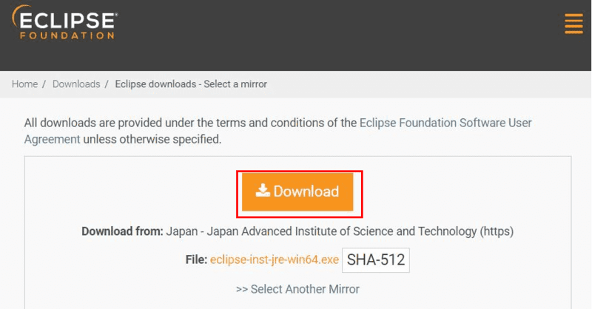

STEP 5: Open Download EXE
- Now go to File Explorer and click on "Downloads" after that click on the "eclipse-inst-jre-win64.exe" file for installing Eclipse IDE.
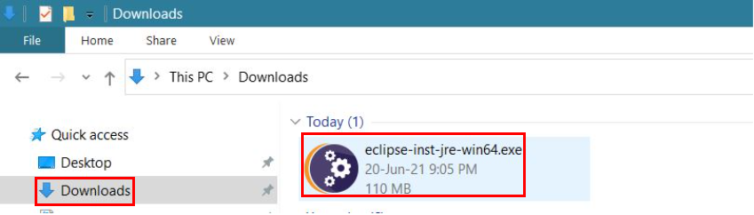
STEP 6: Install Eclipse
- Then, click on "Eclipse IDE for Java Developers".
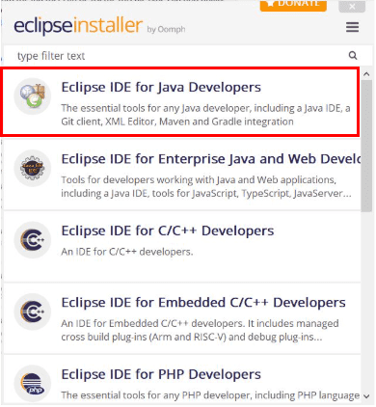

STEP 7: Then, click on the "Install" button.

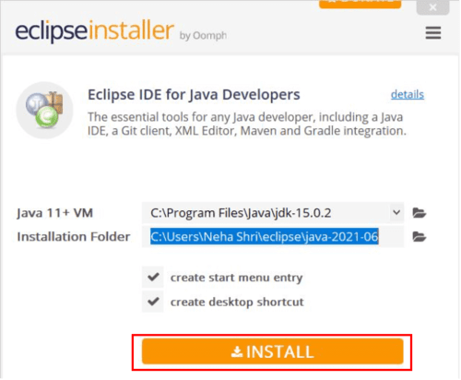
Step 8: Create New Project
Now click on "Create a new Java project".
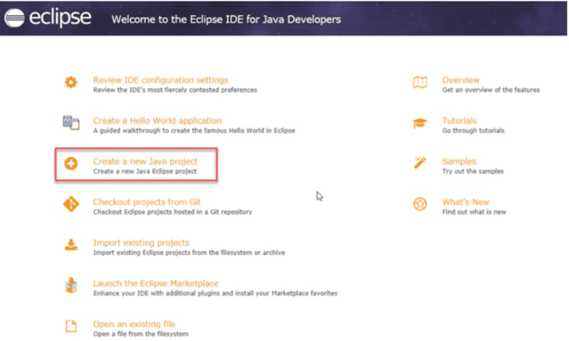
STEP 9:Create a new java project
- By clicking on the File menu and choosing New → Java Project.
- By right clicking anywhere in the Project Explorer and selecting New → Java Project.
- By clicking on the New button ( ) in the Tool bar and selecting Java Project.
STEP 10: Enter the Project Name
- Select the Java Runtime Environment (JRE) or leave it at the default
- Select the Project Layout which determines whether there would be a separate folder for the source codes and class files. The recommended option is to create separate folders for sources and class files.
- 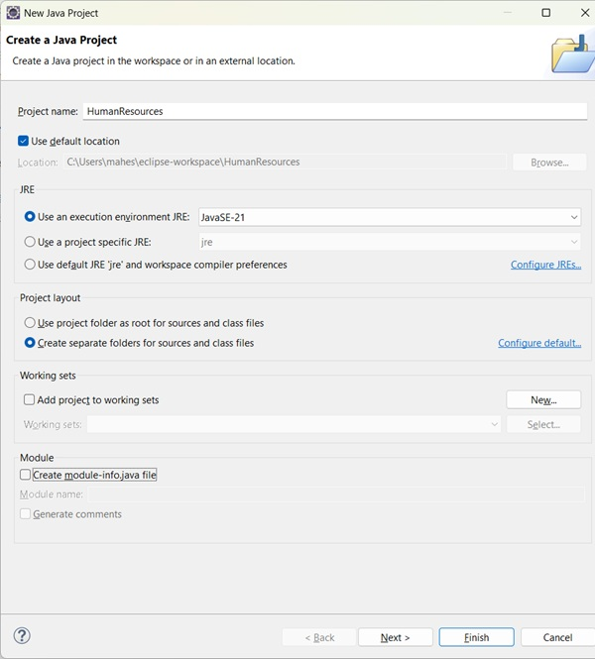
STEP 11: Create a new java package
- By clicking on the File menu and selecting New → Package.
- By right click in the package explorer and selecting New → Package.
- By clicking on the package icon which is in the tool bar( ).
STEP 11:
- Enter/confirm the source folder name.
- Enter the package name.
- Click on the Finish button.
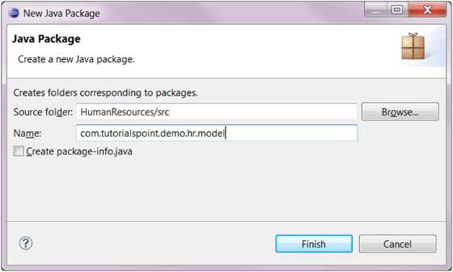

STEP 12:Create a New Java class.
- By clicking on the File menu and selecting New → Class.
- By right clicking in the package explorer and selecting New → Class.
- By clicking on the class drop down button ( ) and selecting class ( ).
STEP 13:
- Ensure the source folder and package are correct.
- Enter the class name.
- Select the appropriate class modifier.
- Enter the super class name or click on the Browse button to search for an existing class.
- Click on the Add button to select the interfaces implemented by this class.
- Examine and modify the check boxes related to method stubs and comments.
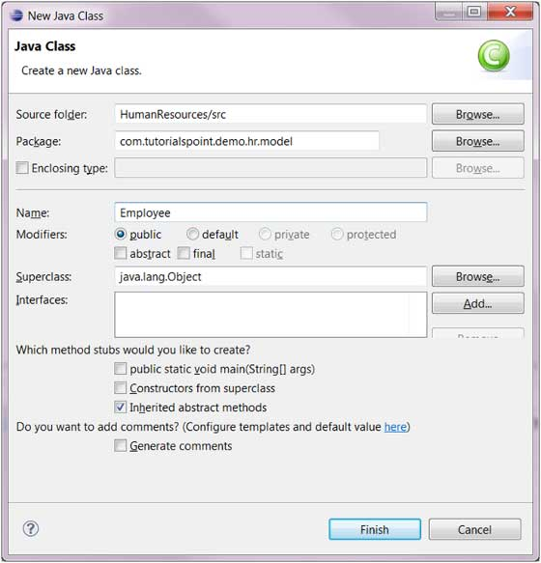

STEP 14: Class created successfully.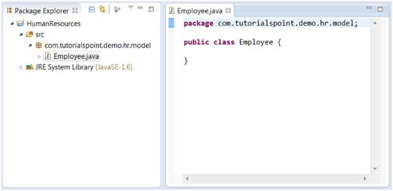

BASIC PROGRAMS:
Program 1: Hello World Program
Source Code:
class HelloWorld {
public static void main(String[] args) {
System.out.println("Hello World");
}
}
Output:
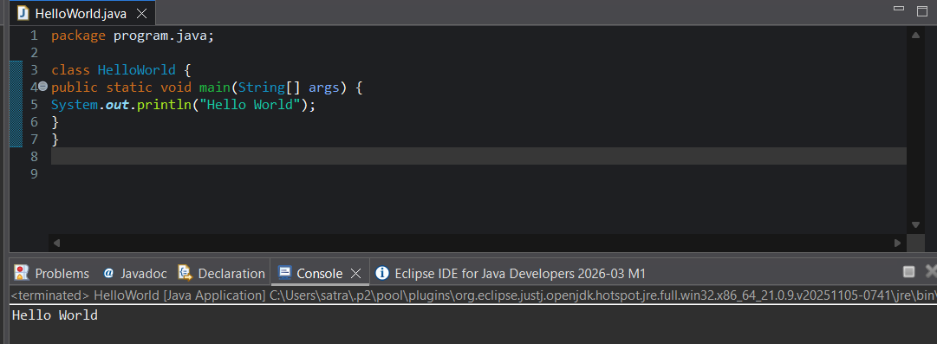
Hello World
Program 2: Display Personal Details
Source Code:
class DisplayInfo {
public static void main(String[] args) {
System.out.println("Name: Anitha");
System.out.println("Age: 20");
}
}
Output:
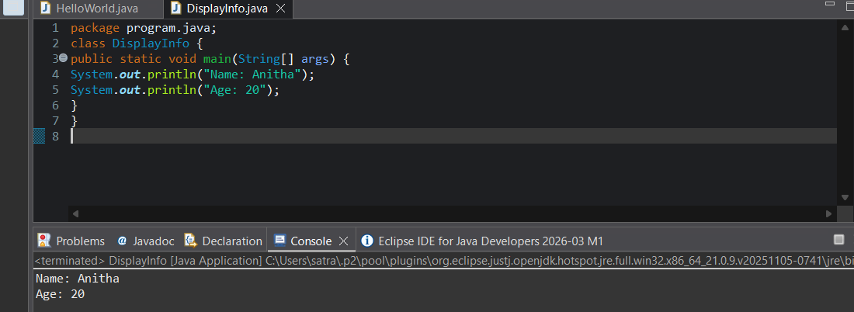
Name: Anitha
Age: 20
Program 3: Addition of Two Numbers
Source Code:
class AddTwoNumbers {
public static void main(String[] args) {
int a = 10, b = 20;
System.out.println("Sum = " + (a + b));
}
}
Output:
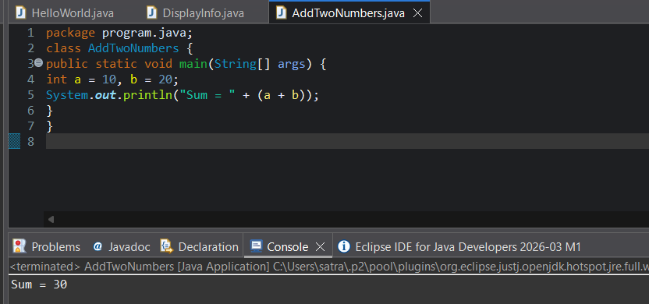
Sum = 30
Program 4: Area of a Rectangle
Source Code:
class AreaRectangle {
public static void main(String[] args) {
int length = 10, breadth = 5;
System.out.println("Area = " + (length * breadth));
}
}
Output:
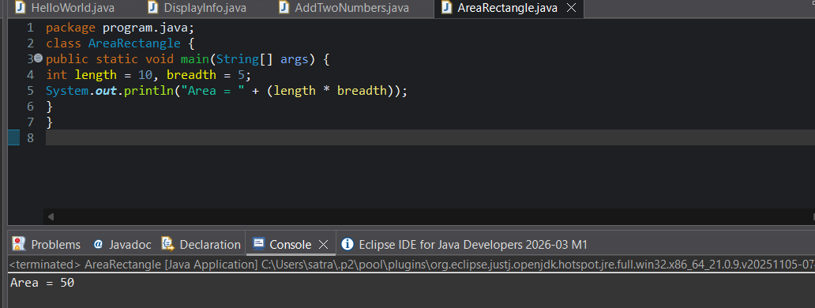
Area = 50
Program 5: Simple Interest Calculation
Source Code:
class SimpleInterest {
public static void main(String[] args) {
int p = 1000;
int r = 5;
int t = 2;
int si = (p * r * t) / 100;
System.out.println("Simple Interest = " + si);
}
}
Output:
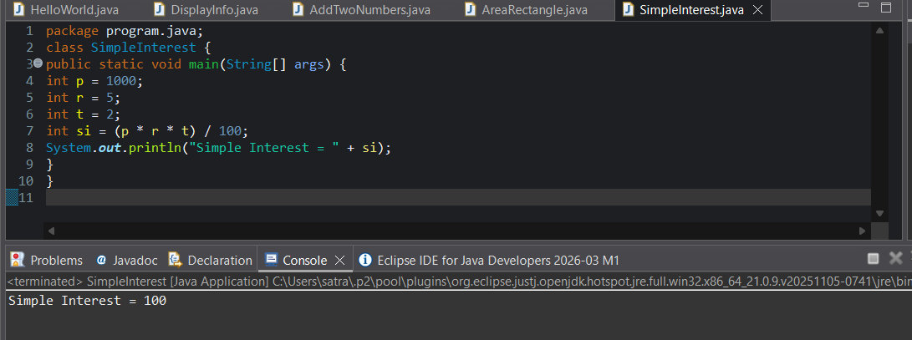
Simple Interest = 100

POST LAB EXERCISE
- Write a Java program to display your name and department.
class DisplayInfo {
public static void main(String[] args) {
System.out.println("Name: Satrapathy");
System.out.println("Department: Computer Science");
}
}
- Modify the program to print the output in same line.
Use print() instead of println():
class DisplayInfo {
public static void main(String[] args) {
System.out.print("Name: Satrapathy ");
System.out.print("Department: Computer Science");
}
}
- What happens if main() is written without static?
If main() is written without static, the program will not run.
The JVM cannot call the main() method without creating an object, so it gives a runtime error.

- Why is Java called platform independent?
Java is called platform independent because Java programs are compiled into bytecode, which can run on any system that has a JVM, regardless of the operating system.

- Write a program to find the cube of a number.
class Cube {
public static void main(String[] args) {
int num = 5;
int cube = num * num * num;
System.out.println("Cube of " + num + " is: " + cube);
}
}

Result:

Thus the Java IDE was successfully installed and a simple Java program was executed.

ASSESSMENT

Description | Max Marks | Marks Awarded
Pre Lab Exercise | 5
In Lab Exercise | 10
Post Lab Exercise | 5
Viva | 10
Total | 30
Faculty Signature

